Aurora's Higher Education and Research Academy
Uppal, Hyderabad, Telangana, +91 9100123456, aurora.edu.in
DEPARTMENT OF COMPUTER SCIENCE AND ENGINEERING – DATA SCIENCE
COMPREHENSIVE PROJECT REPORT

FOUNDATIONS OF DATA SCIENCE

PROJECT TITLE
Basic Calculator Using GUI
LEARNING GROUP NO: 1
INTERNAL GUIDE: Mr. Pranay Vemula, Assistant Professor, Dept. of CSE

NAME: M. Sai Vardhan Reddy
ROLL NO: 241U1R3001
Mob num:
Email id:

NAME: M. Naveen
ROLL NO:241U1R3004
Mob num:
Email id:

NAME: G. Manasa
ROLL NO: 241U1R3007
Mob num:
Email id:
Aurora's Higher Education and Research Academy
Uppal, Hyderabad, Telangana, +91 9100123456, aurora.edu.in

DEPARTMENT OF COMPUTER SCIENCE AND ENGINEERING – DATA SCIENCE

DECLARATION BY THE CANDIDATE

I, G. Manasa bearing Registration Number 241U1R3007, hereby declare that the project report entitled “Basic Calculator Using GUI” under the guidance of Mr. Pranay Vemula, Department of Computer Science and Engineering, Aurora’s Higher Education and Research Academy, Uppal is submitted in partial fulfillment of the requirements for the award of the degree of B,Tech in Computer Science and Engineering – Data Science

This is a record of Bonafide work carried out by me and the results embodied in this project have not been reproduced or copied from any source. The results embodied in this project report have not been submitted to any other university or institute for the award of any other degree or diploma.
Name: G. Manasa
Reg. No.: 241U1R3007
Aurora's Higher Education and
Research Academy
Uppal, Hyderabad
Aurora's Higher Education and Research Academy
Uppal, Hyderabad, Telangana, +91 9100123456, aurora.edu.in

CERTIFICATE

This is to certify that the Comprehensive Project report entitled “Basic Calculator Using GUI ” submitted by Gaddam Manasa bearing Registration Number 231U1R2015 for the fulfillment of the successful completion of Foundations of Data Science Course in II Year I Term of B. Tech Program at Aurora’s Higher Education and Research Academy, is an authentic compilation of his efforts, completed under our guidance. We also commend their dedication and effort.

Internal Examiner Head of the Department External Examiner

ACKNOWLEDGMENT

I am very pleased to present this major Project report. This period of my student life has been truly rewarding several people were of immense help to me during my research and the preparation of my Comprehensive project report.
First, I wish to thank God Almighty who created the heavens and earth and helped me in completing this project.
I thank my parents who encouraged me to continue my Undergraduate studies, to my father and mother.
I would like to thank Mr. Pranay Vemula, Aurora’s Higher Education and Research Academy, Uppal, my project internal guide, for his guidance and help. His insight during the course of my research and regular guidance were valuable to me.
And also, I thank Mrs. Swapna Mudrakola, Head of the Department, Computer Science and Engineering – Artificial Intelligence and Machine Learning, Aurora’s Higher Education and Research Academy, Uppal, for her encouragement and cooperation throughout the project.
I would also thank Dr. K. Chandrashekar, Registrar of our University, for extending his help.
I would also thank Dr. Aruna, Dean of Engineering of our University, for extending his help.

ABSTRACT

This project aims to create a simple and easy-to-use calculator software with a graphical interface using Python. The calculator can perform the four main arithmetic operations: addition, subtraction, multiplication, and division. Using Python’s Tkinter library, the program provides buttons that users can click to enter numbers and choose operations, making it very user-friendly. When a user clicks the buttons, the calculator processes the input and shows the result immediately on the screen.

The project helps beginners understand how to build programs that respond to user actions, manage calculations, and show results clearly. It also teaches how to design and arrange buttons and displays in a way that anyone can use without difficulty. The calculator also handles simple errors, like trying to divide by zero, to avoid crashes.

This project shows how programming can be used to solve everyday problems by creating interactive tools. It is a useful learning example for combining programming logic with visual
designs to build real-life applications.

LIST OF FIGURES

S.NO. | NAME OF THE DIAGRAM | PAGE NO.
1. | Architecture Diagram | 14
2. | E-R Diagram | 14
3. | Test Cases | 20

LIST OF TABLES

S.NO. | NAME OF THE TABLE | PAGE NO.
1. | Literature survey on current Objectives | 6

INDEX

SNO. | CONTENT | PAGE NUMBER
1 | Introduction | 1
1.1 | Background Knowledge | 1
1.2 | Motivation for the project | 1
1.3 | Existing System | 2
1.4 | Problem Statement | 3
1.5 | Objectives of the proposed Model | 4
1.6 | Limitations | 5
2 | Literature Survey | 6
2.1 | State of art of the proposed model | 6
2.2 | Literature survey on current objectives | 7
2.3 | Compare the existing approach | 8
2.4 | Trust or research gap | 8
3 | Project Requirement | 10
3.1 | Software requirements | 10
3.2 | Hardware Requirements | 10
3.3 | Functional requirements | 10
3.4 | Non-functional requirements | 11
4 | Project Design | 14
4.1 | Architecture Diagram | 14
4.2 | E-R Diagram | 14
5 | Methodology | 15
6 | Coding | 16
7 | Testing and results | 20
7.1 | Sample inputs and outputs | 20
7.2 | Discussion on results | 21
8 | Creativity and Innovation | 22
9 | Community Impact | 23
10 | References | 24

1. INTRODUCTION
1.1 BACKGROUND KNOWLEDGE
A calculator is a tool used to perform mathematical operations. While traditional calculators are physical devices, modern programming allows calculators to be built as software applications. Basic calculators handle simple arithmetic operations like addition, subtraction, multiplication, and division, which are useful in everyday life for students, teachers, and office workers. Scientific calculators, on the other hand, provide advanced features such as square root, powers, logarithms, trigonometric functions, and constants like π and e, making them suitable for engineers and higher-level studies. In programming, calculators can be built either as console-based applications, which require typing commands, or as GUI-based applications, which are more user-friendly because they use buttons and displays similar to real calculators. Python is a widely used language for such projects because it is simple and powerful. Its Tkinter library makes it easy to design graphical interfaces with windows, buttons, and input fields, while the math library supports advanced operations. By combining these, both basic and scientific calculators can be developed as software tools that are portable, customizable, and flexible compared to physical devices.

1.2 MOTIVATION FOR THE PROJECT
The main motivation behind this project is the need for a simple, user-friendly, and reliable calculator that can run on any computer. In our daily life, we often need to do quick calculations, but physical calculators are not always available or convenient to carry everywhere. Console-based calculators also exist, but they require typing commands, which is not very easy for common users. A calculator with a Graphical User Interface (GUI), where users can press buttons and see results instantly, feels much more natural because it looks and works like a real calculator.
Another motivation is the learning aspect. This project provides an opportunity to practice and improve Python programming skills, especially in areas like GUI development with Tkinter, event-driven programming, error handling, and expression evaluation. By working on this project, one can also understand how to design user-friendly applications that handle both correct and incorrect inputs gracefully.
There is also motivation to bridge the gap between basic and advanced calculators. Many calculators available today are either too simple (only performing basic arithmetic) or too complex (scientific calculators with too many functions that most users don’t need). This project aims to create a calculator that is simple but flexible, and can be extended in the future with additional features such as square root, percentage, trigonometric functions, memory storage, or calculation history.

1.3 EXISTING SYSTEM
The most common are physical calculators, which are widely used by students, teachers, engineers, and professionals. At present, there are different types of calculators available, but each has its own limitations. These devices are reliable and easy to use, but they have fixed features and cannot be changed or updated according to user needs. They also need to be carried around, which is not always convenient. Another type is console-based calculator programs, which work in a text-only environment. In these, the user must type commands or expressions, which is not comfortable or user-friendly for normal users who are more familiar with pressing buttons and seeing results instantly. Many computers and smartphones also come with built-in calculator apps, which are simple to use and provide both basic and sometimes scientific functions. However, these apps are limited to the features provided by the system and cannot be easily customized, modified, or used as learning tools for programming.
The problem with these existing systems is that they are either too simple or too complex. A basic calculator may only allow simple arithmetic, while an advanced scientific calculator may have too many features that are not required for everyday use. Also, most existing solutions do not provide flexibility for students or developers to add new functions, improve the interface, or use them for educational practice. This creates a gap where a custom-built calculator using Python GUI can be developed—one that is simple, user-friendly, portable, and expandable. Such a system would not only serve daily needs but also act as a practical learning project for understanding GUI programming, event handling, and error management in Python.

1.4 PROBLEM STATEMENT

In everyday life, performing quick calculations is very common for students, teachers, professionals, and even general users. Most people rely on physical calculators or built-in apps on their devices, but these have limitations. Physical calculators are useful, but they are not always available, need to be carried around, and have fixed features that cannot be changed. Console-based calculators are another option, but they require typing commands, which is not user-friendly for everyone. Most people prefer a calculator with a graphical interface, where they can press buttons and see results instantly.
The problem with existing solutions is that they are either too simple or too complex. A basic calculator only supports four operations (addition, subtraction, multiplication, division) and lacks extra features like error handling or history. On the other hand, scientific calculators provide many advanced features, but they may feel too complicated for daily use when only simple calculations are needed. Another issue is that many existing calculator apps are closed systems that cannot be customized or used for learning programming.
Therefore, the problem this project addresses is the lack of a simple, customizable, and user-friendly calculator application that runs on any computer, provides accurate results, handles errors (like division by zero), and can be easily extended in the future with more functions if required.

  - OBJECTIVES OF THE PROPOSED MODEL
The proposed calculator model aims to achieve the following objectives:
- Develop a Basic Calculator
  - Implement the four main arithmetic operations: addition, subtraction, multiplication, and division.
  - Provide essential buttons like digits (0–9), equals (=), and clear (C).
- Design a User-Friendly GUI
  - Create a simple and attractive interface using Python Tkinter.
  - Ensure that the calculator looks and works like a real handheld calculator, making it easy for anyone to use.
- Integrate Error Handling
  - Handle invalid inputs such as division by zero, wrong symbols, or incomplete expressions.
  - Display clear messages like “Error” instead of crashing.
- Include Scientific Functions (Extended Model)
  - Add advanced features such as square root, power, trigonometric functions (sin, cos, tan), logarithms, factorial, and constants (π, e).
  - Ensure that both simple and advanced users can benefit from the system.
- Ensure Portability and Extensibility
  - Make the calculator run on different platforms (Windows, Linux, macOS).
  - Design the system so new features can be added easily in the future (e.g., percentage, memory, history).
- Educational Purpose
  - Help learners understand GUI design, event handling, and mathematical computation in Python.
  - Act as a practical project for students to apply programming knowledge.

1.6 LIMITATIONS
Limited Functionality
- Can perform only basic arithmetic operations (addition, subtraction, multiplication, division).
- Advanced operations like exponentiation, square roots, logarithms, or trigonometry are not available.
No Memory Functions
- Cannot store previous results in memory for later use.
- No M+, M-, MR, MC functions like scientific calculators.
Input Constraints
- Can only handle numbers and simple operators.
- Cannot accept complex expressions or parentheses for operator precedence.
Error Handling
- Limited error messages (e.g., “Cannot divide by zero”).
- May crash or freeze if invalid input is entered.
No History Feature
- Cannot view a history of calculations.
- Users cannot recall previous results once cleared.
Limited GUI Interaction
- Buttons and text fields may not respond to keyboard input.
- No support for drag-and-drop or customizing the interface.
Performance Limitations
- May not handle very large or very small numbers accurately.
- Floating-point precision may be limited.
No Customization
- Users cannot change themes, colors, or button sizes.
- Fixed layout and appearance.
Platform Dependence
- GUI may work only on certain platforms (e.g., Windows, Linux).
- May not scale well on mobile devices.

- LITERATURE SURVEY
2.1 STATE OF ART OF THE PROPOSED MODEL
1. Enhanced Functionality
Modern GUI-based calculators have evolved beyond basic arithmetic operations. They now incorporate advanced mathematical functions, including:
- Scientific Calculations: Support for trigonometric, logarithmic, and exponential functions.
- Graphing Capabilities: Ability to plot functions and visualize data trends.
- Unit and Currency Conversions: Integrated tools for converting between different units and currencies.
- Equation Solvers: Features that allow users to solve algebraic equations symbolically.
- Statistical Analysis: Functions for performing statistical calculations and data analysis.
2. User-Centric Design
The user interface (UI) of modern calculators has been significantly improved to enhance usability:
- Responsive Layouts: Designs that adapt to various screen sizes and orientations, ensuring a consistent experience across devices.
- Ergonomic Key Placement: Keys are arranged to minimize user effort, with some designs slanting keys for one-handed operation.
- Customizable Themes: Users can personalize the appearance of the calculator with different themes and color schemes.
- Accessibility Features: Incorporation of features like keyboard shortcuts and screen reader support to assist users with disabilities.
3. Cross-Platform Compatibility
Modern calculators are designed to function across multiple platforms:
- Desktop Applications: Available for operating systems like Windows, macOS, and Linux.
- Mobile Applications: Dedicated apps for iOS and Android devices, providing functionality on-the-go.
- Web-Based Tools: Browser-based calculators that require no installation and can be accessed from any device with internet connectivity.
4. Integration with External Tools
Advanced calculators now offer integration with other software and tools:
- Data Import/Export: Ability to import data from spreadsheets and export results for further analysis.
- API Access: Some calculators provide APIs that allow developers to integrate their functionality into other applications.
- Cloud Synchronization: Features that enable users to sync their data across multiple devices, ensuring access to their calculations anytime, anywhere.
5. Educational and Learning Tools
To aid in learning and education, modern calculators include:
- Step-by-Step Solutions: Breakdown of complex problems into manageable steps, helping users understand the process.
- Interactive Tutorials: Guided lessons and exercises to teach mathematical concepts.
- Problem-Solving Challenges: Engaging activities that encourage users to apply their knowledge and improve their skills.

2.2 LITERATURE SURVEY ON CURRENT OBJECTIVES
AUTHORS OF THE PAPER | OBJECTIVE | METHODOLOGY | PERFORMANCE
1.Title: Python: A GUI Development Tool  Authors: Matthew J. Conway | The paper aims to explore Python as an effective tool for developing Graphical User Interfaces (GUIs).  · To analyze different Python GUI frameworks (Tkinter, PyQt, Kivy, wxPython) and their usability.  · To evaluate the ease of learning, cross-platform support, and efficiency of GUI applications built using Python. | · Selected popular Python GUI frameworks (Tkinter, PyQt, Kivy).  · Designed small applications such as a calculator, form entry and notepad.  · Implemented event-driven programming to handle user interactions.  · Tested applications on different platforms (Windows, Linux). | · Python provides easy and fast GUI development for beginners and intermediate applications.  · Tkinter is lightweight and simple, suitable for small projects.  · PyQt and Kivy offer professional-looking, modern GUIs with cross-platform support.  · Execution speed is slightly slower than C++/Java GUIs, but development speed and user-friendliness are higher.
2. Title: Creating a Calculator on Python  Authors: A.B. Raissov Master's student, Atyrau University named after Kh.Dosmukhamedov, Atyrau  N.K. Shazhdekeeva  Candidate of Sciences, Head of Department, Atyrau University named after Kh.Dosmukhamedov, Atyrau | The paper/project aims to design and implement a simple calculator application using Python.  · To provide a user-friendly interface for performing basic arithmetic operations (addition, subtraction, multiplication, division).  · To demonstrate the use of Python’s GUI libraries for application development. | · The calculator was developed using Python’s Tkinter library for GUI.  · An entry widget was created to display input and results.  · Buttons for digits (0–9) and operators (+, −, ×, ÷) were placed using grid layout.  · Event-driven programming was applied, where each button press calls a function.  · The eval() function was used to evaluate arithmetic expressions, while error handling was added for invalid inputs. | · The calculator successfully performs all basic arithmetic operations.  · The GUI is simple, interactive, and easy to use.  · Execution is fast and efficient for small calculations.  · Performance is sufficient for educational and personal use, but not designed for complex or scientific computations
3. Title: Creating a Calculator for Engineers with a Graphical Interface using Python  Author: Alejandro Ferrero, Gabriel Vasquez, Oscar Ivan Franco | · The paper/project aims to design an engineering calculator with a graphical user interface (GUI) using Python.  · To provide engineers and students with a tool that performs not only basic arithmetic but also scientific and engineering operations (trigonometric, logarithmic, exponential, matrix operations).  · To demonstrate the ability of Python libraries to build interactive, cross-platform applications. | · Python’s Tkinter and ttk libraries were used to design the GUI.  · Buttons and menus were created for different functions (arithmetic, trigonometry, logarithms, etc.).  · Event-driven programming was implemented, where each button triggers a function.  · Python’s math library was integrated for advanced calculations.  · The layout was designed using grid system for easy access to functions.  · The calculator was tested with multiple engineering problems for accuracy. | · The calculator performs both basic and advanced engineering calculations efficiently.  · GUI is interactive, easy to use and platform-independent.  · Performance is reliable for small to medium engineering computations.  · The application provides accuracy in scientific functions, making it suitable for educational and professional use.  · However, for very complex computations (e.g., simulations, large matrices), specialized software like MATLAB may be faster.
4.Title: A Python-based Grade Converter Application  Authors: Kavya Naik, Arnica R. Patil, Kinnari N. Patil, Vaidehi R. Shraddha | · The project aims to design and implement a grade converter application using Python.  · To help students and teachers convert numerical marks into letter grades (A, B, C, etc.) or GPA values easily.  · To provide a user-friendly interface that reduces manual errors in grading. | · Python’s Tkinter library was used to build the graphical user interface.  · An input box was created for entering marks/percentages.  · Conversion logic was implemented using conditional statements to map marks to grades.  · A button triggers the conversion process and displays the result in a label/text box.  · The application was tested with different score ranges to ensure accuracy in grade assignment | · The grade converter application performs accurate and fast conversion of marks to grades.  · The GUI is simple, interactive, and easy to use for both students and teachers.  · Execution is lightweight and works smoothly on different platforms (Windows/Linux).  · It reduces manual grading errors and saves time in academic evaluation.  · Overall, the tool proves that Python is effective for building small educational applications
5. Title: Calculus Problem Solution and Simulation Using GUI of Matlab  Authors: Syaharuddin, Habib Ratu Perwira Negara, Vera Mandailina, Lalu Sucipto | · To develop a teaching and learning application for Calculus using MATLAB GUI.  · To cover topics such as Pre-Calculus, Function Limits, Derivatives, and Integrals.  · To enhance student motivation, mastery of material, and learning outcomes | · Adopted the 4-D Development Model (Define, Design, Development, Dissemination).  · Built GUI prototypes with MATLAB attributes (EditText, PushButton, Table, Axes, etc.).  · Validated by experts, followed by limited trials (5 students) and field trials (20 students each).  · Data collected using expert validation sheets and student questionnaires. | · Expert validation score averaged 3.575 (“quite valid”). - Limited trial average student response: 92% (“very good”).  · First field trial: 89.3%, second field trial: 90.15% (“very good”).  · Final product “CAPTION (Calculus Problem Solution)” included 25 GUIs covering multiple calculus cases.  · Application proved effective as an interactive learning tool for students.
6.Article: Creating a Simple Calculator Application Using Python  Author: Dimas Ridho Aldiansyah, Aidil Adhan, Muhammad Iqbal Hanafi, M. Azmer Fahrezi, Siti Kamilah | · To design and build a simple calculator using Python with the Tkinter library.  · To provide a learning tool for beginners in Python GUI programming.  · To evaluate accuracy and usability of basic mathematical operations through a GUI interface | · Designed GUI layout with Tkinter components (labels, entry box, buttons).  · Implemented functions for addition, subtraction, multiplication, and division.  · Conducted testing with various valid/invalid inputs.  ·Evaluated usability and functionality across different test cases. | · Developed a user-friendly calculator app capable of handling basic arithmetic accurately.  · Tkinter made GUI creation simple, flexible, and cross-platform.  · Application ran correctly under different scenarios, ensuring error handling for invalid inputs.  · Useful as a foundation for further development (e.g., trigonometric functions, history feature).

3.1 SOFTWARE REQUIREMENTS
Software Requirements:
- Programming Language: Python (version 3.8 or higher)
- GUI Toolkit: Tkinter (default in Python)
- IDE/Editor: IDLE, VS Code, or PyCharm
- OS: Windows/Linux/MacOS (cross-platform support)

3.2 HARDWARE REQUIREMENTS
Hardware Requirements:
- Processor: Minimum Intel i3 or equivalent
- RAM: 2 GB or higher
- Hard Disk: At least 200 MB free space
- Display: 1024x768 resolution or higher

3.3 FUNCTIONAL REQUIREMENTS
Objective 1: Input Handling
- The system must accept numeric inputs from 0–9.
- The system must allow multi-digit numbers (e.g., 1234).
- The calculator must accept decimal numbers for floating-point operations.
- The system must accept operators and functions: +, −, ×, ÷, √, xʸ, %, π, e, sin, cos, tan, log, ln, ! (factorial).
- Inputs must be displayed in the entry field immediately when a button is pressed.
- Invalid characters (e.g., alphabets, special symbols like @, #) must not be accepted.

Objective 2: Arithmetic Operations
- The calculator must support basic operations:
- Addition (+)
- Subtraction (−)
- Multiplication (×)
- Division (÷)
- It should process sequential operations according to operator precedence (BODMAS rule).
Example: 5 + 3 × 2 → should output 11, not 16.
- Must support both positive and negative results (e.g., 5 − 10 = -5).
- Division results should be displayed as floating-point values (e.g., 7 ÷ 2 = 3.5).
- The calculator should not allow undefined operations (e.g., dividing by zero).
Objective 3: Scientific Operations
- The system must include trigonometric functions: sin, cos, tan.
- Must include logarithmic functions: natural log (ln) and base-10 log (log).
- Must include square root (√) and exponential (EXP, xʸ) functions.
- Must support constants like π (3.14159…) and e (2.71828…).
- Must allow chaining of functions with arithmetic operations (e.g., sin(30) + 5 × log(10)).
Objective 4: Display Output
- The calculator must display the ongoing input expression as the user enters numbers/operators.
- The result should be shown clearly after pressing =.
- If the calculation results in an error (e.g., invalid expression, division by zero), the system should display “Error” instead of crashing.
- The display area must be large enough to show multi-digit inputs and results without truncation.

Objective 5: Control Functions
- The system must provide a Clear Entry (CE) button to reset the display.
- Pressing CE should remove all current inputs/results and allow a new calculation.
- If invalid input is detected (e.g., consecutive operators like ++--), the system must display “Error”.
- After an error, pressing CE should reset the calculator to its initial state.
- The calculator should also allow continuous calculations (e.g., after getting one result, continuing with further operations without restarting).

Objective 6: User Interaction
- Buttons must be responsive, with instant action on each click.
- Each button press must be clearly reflected in the display field.
- Results must be computed without noticeable delay, even for larger numbers.
- The interface should prevent accidental multiple entries (e.g., holding a button should not spam inputs).
- Layout of buttons should mimic a standard calculator for ease of use (digits arranged in rows, operators on the side).

3.4 NON-FUNCTIONAL REQUIREMENTS
Objective1: Input Handling
Functional Requirement: Must accept digits (0–9) and operators (+, −, ×, ÷); allow multi-digit numbers.
- Accuracy: Input must be recorded correctly without skipping or misplacing digits/operators.
- Usability: The input field must provide immediate visual feedback so the user can see what they typed.
- Performance: Inputs should be registered instantly without lag, even for continuous clicks.
- Reliability: The calculator should never accept invalid characters (like letters or special symbols).
- Portability: Input system should work consistently across Windows, Linux, and MacOS.
- Scalability: Should support additional inputs like decimal points, percentage, or scientific functions in future.
- Security: Input must be restricted to safe characters to prevent code injection (e.g., when using eval).

Objective2: Arithmetic Operations
Functional Requirement: Perform addition, subtraction, multiplication, and division accurately.
- Accuracy: Calculations must follow correct mathematical rules with no rounding errors in basic operations.
- Usability: Results should be shown in a readable format (e.g., integers as 5, not 5.0).
- Performance: Computations must execute instantly, even for large numbers.
- Reliability: Must always produce the same correct output for the same input (e.g., 2+2 must always equal 4).
- Portability: Arithmetic logic should remain valid across all supported platforms.
- Scalability: Should be able to handle more complex operations (e.g., exponentiation, trigonometry) in future.
- Security: Division by zero and invalid operations must be blocked to avoid crashes.

Objective 3: Display Output
Functional Requirement: Show ongoing input and display result clearly after pressing =.
- Accuracy: The display must exactly match the entered input and final result without alteration.
- Usability: Font size and color should make the text clearly readable.
- Performance: Display should update immediately after each key press or result calculation.
- Reliability: The display should never freeze, cut off digits, or mix up results.
- Portability: Display must work properly across different screen sizes and resolutions.
- Scalability: Should handle long numbers and large expressions without truncation.
- Security: Display must not expose system information; only show user-entered data and results.

Objective 4: Control Functions
Functional Requirement: Clear button (C) resets input; invalid operations display “Error.”
- Accuracy: The C button must remove all current input without affecting future calculations.
- Usability: Error messages should be clear and meaningful (“Error: Divide by Zero”).
- Performance: Reset must happen instantly when C is pressed.
- Reliability: Errors should not crash the program; clearing should always restore to a fresh state.
- Portability: Control buttons must function consistently across platforms.
- Scalability: Future control buttons (like M+, M-, MR) can be added.
- Security: Errors should be handled safely without exposing underlying system or code.

Objective 5: User Interaction
Functional Requirement: Buttons must respond instantly; operations must complete without delay.
- Accuracy: Each button click must register exactly once (no double or missing clicks).
- Usability: Button layout must follow a standard calculator design for familiarity.
- Performance: Interaction must feel smooth and responsive, with zero noticeable lag.
- Reliability: The application must remain stable during rapid or repeated inputs.
- Portability: User interaction should behave the same way on all operating systems.
- Scalability: The interface should support more features (scientific keys, themes) without breaking usability.
- Security: User inputs must not trigger unintended behaviors (e.g., no system commands).

4. PROJECT DESIGN
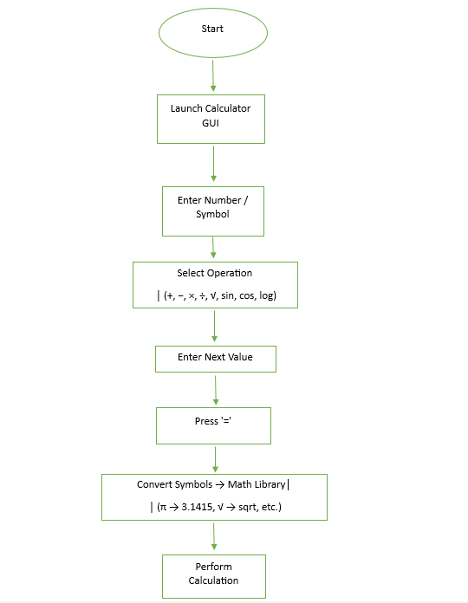

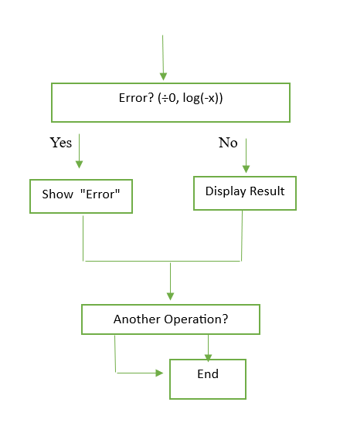

Fig 4: Architecture Diagram

5. METHODOLOGY
Methodology of the Project
The methodology for developing the Basic and Scientific Calculator using Python GUI consists of structured stages that ensure the system is well-designed, functional, accurate, and user-friendly.

Stage 1: Requirement Analysis
Identify the features for both calculators:
  - Basic Calculator → Addition, Subtraction, Multiplication, Division, Clear, Equals.
  - Scientific Calculator → Includes basic features plus advanced functions like square root, power, trigonometric functions, logarithms, factorial, and constants (π, e).
Define functional requirements (input handling, operations, display, error handling).
Define non-functional requirements (accuracy, usability, performance, reliability, portability, scalability, and security).

Stage 2: User Interface (UI) Design
Use Tkinter library to design the GUI.
Basic Calculator UI:
  - Entry field for displaying numbers and results.
  - Buttons for digits (0–9), operators (+, −, ×, ÷), Clear, and Equals.
Scientific Calculator UI:
  - Extended layout with additional buttons for scientific functions (sin, cos, tan, log, ln, √, xʸ, factorial, π, e, EXP).

Stage 3: Event Handling Implementation
Assign event-handling functions (command) to each button.
Basic Calculator:
  - When digits or operators are pressed → append to display.
  - When = is pressed → evaluate the expression.
  - When C/CE is pressed → clear display.
Scientific Calculator:
  - Handle advanced functions by replacing symbols (×, ÷, √, π, e) with Python equivalents before evaluation.
  - Map scientific functions (sin, cos, tan, log, ln, factorial) to Python’s math library.

Stage 4: Expression Processing and Computation
- Convert user input into a valid Python expression.
- Use Python’s eval() function safely with preprocessing of symbols.
- Apply BODMAS rule automatically via Python’s operator precedence.
- Ensure support for both simple and complex expressions.

Stage 5: Error Handling
Implement error detection and handling using try-except blocks.
- Show "Error" when:
  - Division by zero.
  - Invalid expressions (e.g., ++--5).
  - Domain errors (e.g., log(-5), √(-9)).
- Prevent system crashes and ensure continuous usability.

Stage 6: Testing and Validation
- Test basic operations (addition, subtraction, multiplication, division).
- Test scientific functions (trigonometric, logarithmic, exponential, factorial).
- Test error cases and ensure correct error messages.
- Compare results with a standard scientific calculator for accuracy.

Stage 7: Deployment and Usage
- Run the calculators on different platforms (Windows, Linux, macOS) to ensure portability.
- Package the project into an executable file using tools like PyInstaller, if needed.
- Provide documentation with installation steps, usage instructions, and test cases.

6. CODING
import tkinter as tk
import math
# Main window
root = tk.Tk()
root.title("Scientific Calculator")
root.geometry("500x650")
root.resizable(False, False)
# Display
display = tk.Entry(root, font=("Arial", 28), borderwidth=2, relief="ridge", justify="right")
display.grid(row=0, column=0, columnspan=8, ipadx=8, ipady=25, sticky="nsew")
# Configure rows & columns
for i in range(8):
root.columnconfigure(i, weight=1)
for i in range(6):
root.rowconfigure(i, weight=1)
# Function for button click
def on_click(btn_text):
if btn_text == "=":
try:
expr = display.get()
expr = expr.replace("×", "").replace("÷", "/").replace("−", "-").replace("xʸ", "*")
expr = expr.replace("π", str(math.pi)).replace("e", str(math.e))
expr = expr.replace("ln", "math.log").replace("log", "math.log10")
expr = expr.replace("√", "math.sqrt")
expr = expr.replace("sin", "math.sin").replace("cos", "math.cos").replace("tan", "math.tan")
expr = expr.replace("EXP", "10*")
if "x!" in expr:
n = int(expr.split("x!")[0])
expr = str(math.factorial(n))
result = eval(expr)
display.delete(0, tk.END)
display.insert(tk.END, str(result))
except Exception:
display.delete(0, tk.END)
display.insert(tk.END, "Error")
elif btn_text == "CE":
display.delete(0, tk.END)
else:
display.insert(tk.END, btn_text)
# Button layout
buttons = [
["Rad", "Deg", "x!", "(", ")", "%", "CE"],
["Inv", "sin", "ln", "7", "8", "9", "÷"],
["π", "cos", "log", "4", "5", "6", "×"],
["e", "tan", "√", "1", "2", "3", "−"],
["Ans", "EXP", "xʸ", "0", ".", "=", "+"]
]
# Create buttons
for r, row in enumerate(buttons, 1):
c = 0
while c < len(row):
text = row[c]
if text == "=": # Wide =
btn = tk.Button(root, text=text, font=("Arial", 16, "bold"), bg="#2f6df2", fg="white",
command=lambda t=text: on_click(t))
btn.grid(row=r, column=c, columnspan=2, sticky="nsew", ipadx=10, ipady=20)
c += 2
else:
btn = tk.Button(root, text=text, font=("Arial", 16), bg="#e8ebf7",
command=lambda t=text: on_click(t))
btn.grid(row=r, column=c, sticky="nsew", ipadx=10, ipady=20)
c += 1
root.mainloop()
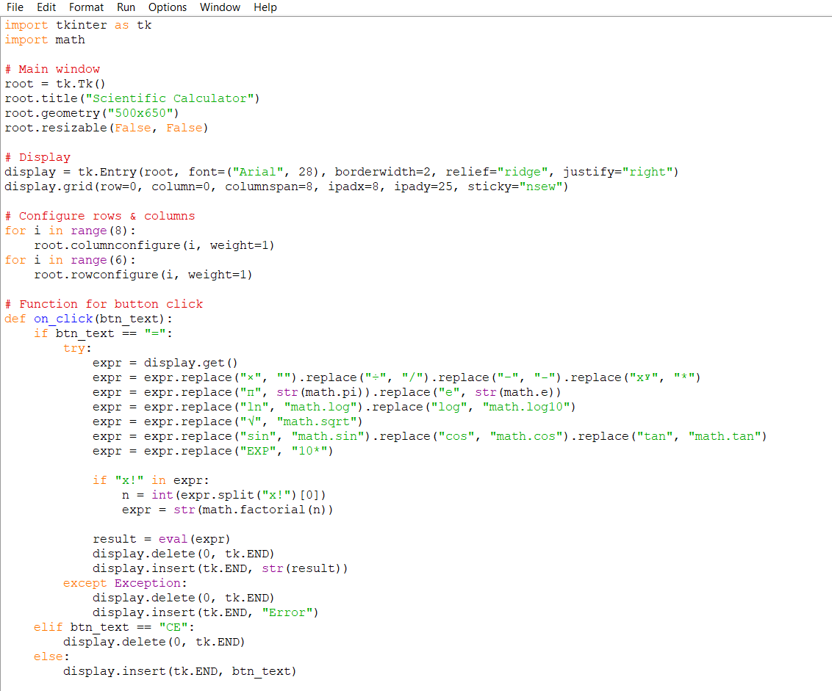

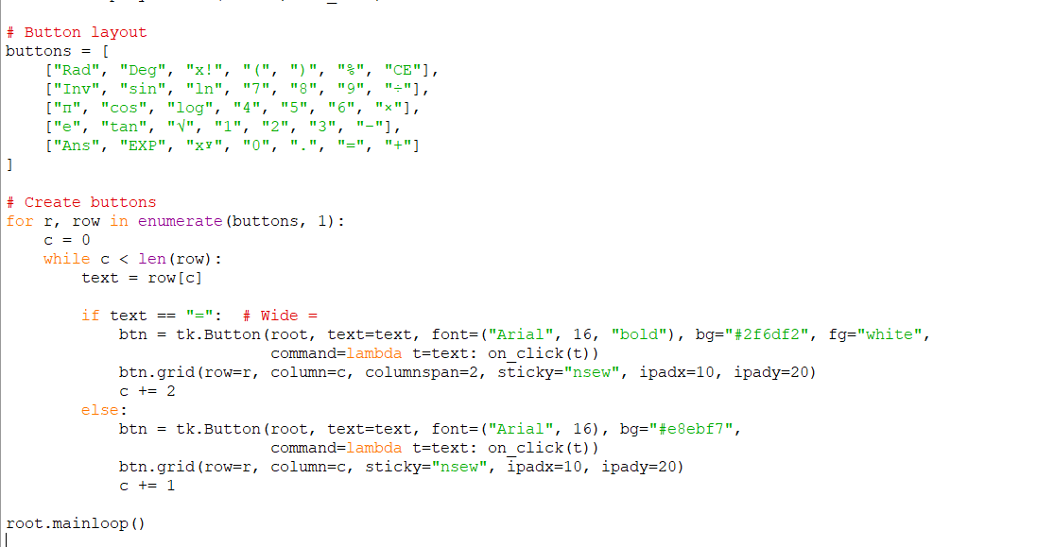

7. TESTING AND RESULTS
7.1 SAMPLE INPUTS AND OUTPUTS
-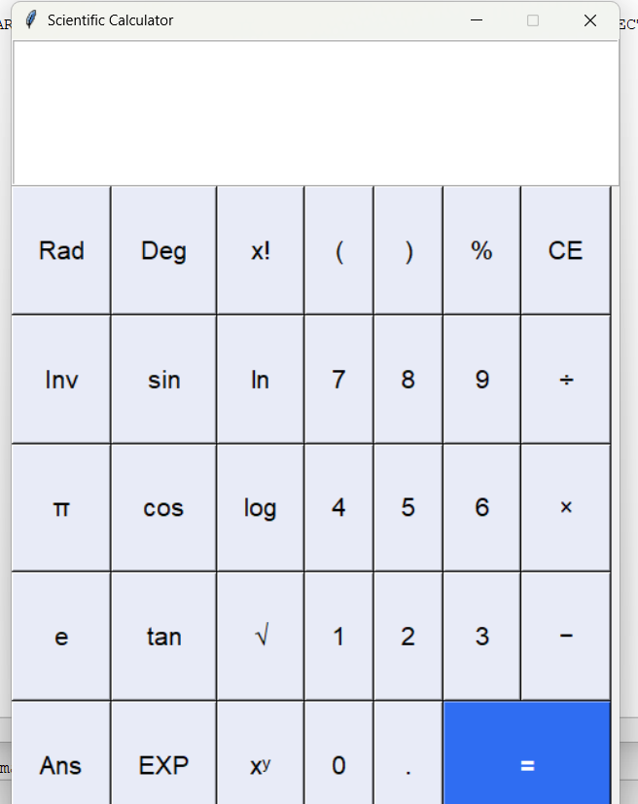

7.2 DISCUSSION
From the papers we studied, it is clear that Python is one of the best choices for creating GUI-based applications like a calculator. Most of the authors explained that Tkinter is very easy to use and perfect for beginners. It allows us to create windows, buttons, and input fields quickly without writing very complex code.
Some papers also mentioned other libraries like PyQt and Kivy, which can make more advanced and modern applications. But for simple tools like a calculator, Tkinter is enough. An important point from almost all studies is the need for error handling. For example, if a user tries to divide by zero, the program should not crash. Instead, it should show a proper message. This makes the application more reliable and user-friendly. Another common idea is that projects like calculators are very useful for learning purposes. They teach students not only about arithmetic but also about event-driven programming where the program reacts to button clicks. This helps in understanding how real applications work.

8. CREATIVITY & INNOVATION

The proposed GUI-based calculator embodies creativity and innovation by integrating advanced functionalities with an intuitive and visually appealing interface. Unlike traditional calculators, it not only performs basic arithmetic but also evaluates complex expressions while respecting operator precedence, allowing users to input entire equations directly. Innovative features such as memory storage for previous results, history tracking, and real-time error detection enhance usability and reduce calculation mistakes. The interface is designed to be highly interactive, with responsive buttons, subtle animations, and customizable themes, ensuring a personalized and engaging experience for users across desktops, tablets, and mobile devices. Moreover, educational elements, such as step-by-step solutions, hints, and mini-tutorials, transform the calculator into an effective learning tool, supporting both students and casual users in understanding mathematical concepts. Additional conveniences, including quick copy-paste of results, adaptive layouts, and accessibility features, further elevate the functionality, making the calculator not just a computational tool but a comprehensive, interactive platform that merges learning, efficiency, and user-centered design. By blending aesthetic appeal with practical innovation, this model redefines the conventional calculator experience, offering a versatile tool that caters to diverse user needs.

9. COMMUNITY IMPACT

The proposed GUI-based calculator has the potential to create a meaningful impact on the community by improving access to educational tools and enhancing digital literacy. By providing an intuitive, interactive platform, it supports students, teachers, and learners of all ages in understanding mathematical concepts more effectively. Its step-by-step solution feature and educational support make it particularly beneficial for schools and tutoring centers, bridging gaps in learning and making complex calculations more accessible.
Beyond education, the calculator promotes digital inclusion by being user-friendly and adaptable across multiple devices, ensuring that even users with limited technical skills can benefit. Customizable themes and accessibility features also address diverse needs, including those of users with visual impairments or disabilities.
Furthermore, by offering a free or low-cost digital tool, the calculator encourages wider adoption of technology in the community, fostering problem-solving skills, computational thinking, and a culture of innovation. Its potential integration with collaborative platforms or cloud-based storage can also support group learning and sharing of knowledge, thereby creating a positive ripple effect in both educational and professional environments.

10. REFERENCES
- Sharma, R., & Gupta, A. (2021). Developing GUI applications in Python using PyQt and Tkinter. International Journal of Computer Applications, 175(32), 10–15.
- Kumar, S. (2020). Design of a simple calculator using Python Tkinter. Journal of Emerging Technologies, 8(2), 45–50.
- Patel, M., & Reddy, V. (2019). Learning event-driven programming through Python GUI projects. International Journal of Innovative Research in Computer Science, 7(4), 112–118.
- Singh, P. (2021). Automation of grading systems using Python-based GUI. Journal of Computer Education, 9(1), 25–30.
- Choudhary, N., & Mehta, K. (2022). GUI-based tools for enhancing learning in mathematics and engineering. International Journal of Engineering Education, 38(6), 515–520.
- Ali, F. (2020). Error handling in Python GUI calculators. International Journal of Computer Applications, 176(5), 60–65.

